 | Epsom & Ewell F.C.  v  Ash United  Tuesday 19th October 2010
For this evening’s Combined Counties League match we welcome the players, officials and supporters of Ash United, today's officials, and our own regular supporters to Moatside.

Last year, home advantage was key in the two fixtures between the sides. We were defeated 4-1 over at Ash in October 2009, but rebounded well in March 2010 to win 5-1 on a great evening at Merland Rise. That match, of course nearly didn’t take place at all due to floodlight issues, but we have no such worries here at Moatside, where we have been made most welcome.

Since our last home match against Molesey when we scraped a point from a 2-2 draw, we have travelled to Hanworth Villa, where we won 1-0 in an entertaining match with quite a few half-chances. Fortunately, Alex McGregor’s scorching drive clinched the points for us. It was a much-improved performance but it was still some way short of the standards our Management team expect.

As you will be aware by now Bracknell Town are our F.A. Vase opponents and this game has now been confirmed for the Sunday 14th November with a 1 p.m. kick off. This is a really good opportunity to get a decent crowd in, and it is down to everyone here today to bring a friend or three along, even those who might normally go and watch another team on a Saturday. Let’s see if we can get a really good crowd along and support our boys in this massive game.

If we win just two matches in this competition we will be guaranteed another exemption next year, which really helps us to keep up with our League fixtures, and the prize money is an added bonus. We also play Camberley Town in the Third Round of the League Cup.

Back to tonight’s game. Ash United present a very stiff test. They are a hard-working team, and have recovered from their slow start to the season, also winning 3-1 at Croydon on Saturday. For our part, we really need to start climbing the table again after a slow start, and this game is followed by another home game on Saturday against Badshot Lea, who of course defeated us earlier in the month and currently sit at the top of the table.

Enjoy the game!

Richard

Cover photo by Gemma Jarman

The players congratulate Paul Borg after his penalty shoot out heroics in the League Cup tie against Worcester Park.

Cherry Red Records Combined Counties League
Premier Division Table
inc Saturday 16th October | P | W | D | L | F | A | Pts | GD
Badshot Lea | 14 | 8 | 5 | 1 | 39 | 18 | 29 | +21
Chertsey Town | 13 | 9 | 1 | 3 | 31 | 13 | 28 | +18
Sandhurst Town | 12 | 7 | 3 | 2 | 27 | 15 | 24 | +12
Camberley Town | 12 | 7 | 2 | 3 | 34 | 19 | 23 | +15
Colliers Wood Utd | 14 | 6 | 5 | 3 | 28 | 19 | 23 | +9
Guildford City | 10 | 6 | 4 | 0 | 25 | 12 | 22 | +13
Egham Town | 13 | 7 | 1 | 5 | 32 | 23 | 22 | +9
Chessington & Hook | 11 | 7 | 1 | 3 | 22 | 17 | 22 | +5
Molesey | 12 | 6 | 3 | 3 | 25 | 14 | 21 | +11
Cove | 10 | 6 | 1 | 3 | 22 | 13 | 19 | +9
Mole Valley SCR | 12 | 4 | 5 | 3 | 28 | 21 | 17 | +7
Epsom & Ewell | 13 | 5 | 2 | 6 | 21 | 25 | 17 | -4
Ash United | 12 | 5 | 1 | 6 | 17 | 30 | 16 | -13
Horley Town | 12 | 4 | 2 | 6 | 17 | 24 | 14 | -7
Hanworth Villa | 12 | 4 | 1 | 7 | 19 | 19 | 13 | 0
Wembley | 13 | 3 | 3 | 7 | 15 | 29 | 12 | -14
Raynes Park Vale | 12 | 2 | 4 | 6 | 15 | 29 | 10 | -14
Croydon (-3) | 12 | 3 | 2 | 7 | 14 | 25 | 8 | -11
Banstead Athletic | 12 | 1 | 3 | 8 | 15 | 31 | 6 | -16
Dorking | 12 | 1 | 3 | 8 | 6 | 30 | 6 | -24
Bookham | 13 | 0 | 2 | 11 | 9 | 35 | 2 | -26

Lucky Day? - 19th October
Played 13 - Won 6 Drawn 3 Lost 4 - F35 A21 - PPG 1.62 - Above Average
Club record against Ash United
Played 11 - Won 5 Drawn 2 Lost 4 - F27 A20 - PPG 1.55 - Above Average
Last Visit
23rd March 2010 - Won 5-1 - Combined Counties League
First Eleven Appearances - (max 18)
Name | Debut | 2010/11 |  |  |  | Career Totals
Name | Debut | App | Sub | Total | Goals | App | Sub | Total | Goals
BEDJ BEDJ Ramzi | 08/08/09 | 11 | 0 | 11 | 3 | 46 | 2 | 48 | 15
BORG Paul | 14/08/07 | 11 | 0 | 11 | 0 | 155 | 0 | 155 | 0
CORMACK Dan | 16/10/10 | 0 | 1 | 1 | 0 | 0 | 1 | 1 | 0
CUFF Tony | 07/08/10 | 13 | 1 | 14 | 2 | 13 | 1 | 14 | 2
FENNESSEY Terry | 18/09/10 | 5 | 0 | 5 | 0 | 5 | 0 | 5 | 0
FOWLER Matt | 07/08/10 | 0 | 8 | 8 | 0 | 0 | 8 | 8 | 0
HARROWING Neil | 15/08/06 | 7 | 0 | 7 | 0 | 35 | 5 | 40 | 0
HATFIELD Jamie | 11/11/06 | 10 | 1 | 11 | 0 | 131 | 7 | 138 | 5
HAYWARD Ben | 07/03/07 | 7 | 2 | 9 | 0 | 142 | 11 | 153 | 7
HEWSON Gary | 18/09/10 | 1 | 1 | 2 | 0 | 1 | 1 | 2 | 0
HOUGH Kyle | 14/08/07 | 14 | 1 | 15 | 10 | 151 | 8 | 159 | 77
JARMAN Mark | 08/08/09 | 16 | 2 | 18 | 7 | 28 | 16 | 44 | 14
JELLEY Tom | 11/02/06 | 7 | 2 | 9 | 0 | 14 | 3 | 17 | 0
MCGREGOR Alex | 08/08/09 | 7 | 10 | 17 | 1 | 42 | 22 | 64 | 3
MOORHOUSE Tommy | 06/03/10 | 8 | 2 | 10 | 2 | 11 | 3 | 14 | 2
NG’BALE Phil | 18/03/06 | 0 | 1 | 1 | 0 | 23 | 10 | 33 | 11
PARIS Joe | 07/08/10 | 16 | 0 | 16 | 0 | 16 | 0 | 16 | 0
READ Chris | 21/02/04 | 0 | 2 | 2 | 0 | 80 | 7 | 87 | 8
REIVE Jamie | 10/10/09 | 6 | 0 | 6 | 1 | 36 | 1 | 37 | 2
RODRIGUES Alex | 05/04/07 | 18 | 0 | 18 | 0 | 181 | 0 | 181 | 2
SAMMUT Dean | 07/08/10 | 12 | 3 | 15 | 0 | 12 | 3 | 15 | 0
SMITH Darren | 27/08/07 | 13 | 0 | 13 | 3 | 39 | 1 | 40 | 10
SMITH Matt | 08/08/09 | 3 | 2 | 5 | 0 | 40 | 10 | 50 | 1
SOLOMON Peter | 07/08/10 | 0 | 2 | 2 | 0 | 61 | 23 | 84 | 2
STEVENS Dave | 16/10/10 | 0 | 1 | 1 | 0 | 0 | 1 | 1 | 0
WEST Charlie | 14/08/07 | 11 | 0 | 11 | 2 | 130 | 5 | 135 | 8
WEST Paul | 17/08/10 | 2 | 6 | 8 | 0 | 2 | 6 | 8 | 0
Club Milestones
Congratulations go to Matt Smith who made his 50th appearance on Saturday at Hanworth Villa. Next up for the 50 should be Ramzi Bedj Bedj or Mark Jarman.

Recent Results and Fixtures
Combined Counties League – Saturday 9th October
Ash United | 2-0 | Banstead Athletic
Chertsey Town | 4-1 | Croydon
Cove | 2-2 | Colliers Wood United
Dorking | 0-0 | Mole Valley SCR
Epsom & Ewell | 2-2 | Molesey
Guildford City | 2-1 | Hanworth Villa
Horley Town | 2-2 | Badshot Lea
Raynes Park Vale | 4-3 | Camberley Town
Sandhurst Town | 1-1 | Egham Town
Wembley | 1-1 | Bookham
Combined Counties League – Tuesday 12th October
Ash United | 1-2 | Cove
Bookham | 2-5 | Badshot Lea
Horley Town | 0-4 | Molesey
Mole Valley SCR | 3-3 | Guildford City
Combined Counties League – Wednesday 13th October
Colliers Wood United | 3-0 | Egham Town
Raynes Park Vale | 1-1 | Dorking
Combined Counties League – Saturday 16th October
Badshot Lea | 3-0 | Dorking
Bookham | 0-3 | Chessington & Hook United
Camberley Town | 1-1 | Banstead Athletic
Colliers Wood United | 2-2 | Chertsey Town
Croydon | 1-3 | Ash United
Egham Town | 2-0 | Cove
Guildford City | 3-1 | Horley Town
Hanworth Villa | 0-1 | Epsom & Ewell
Mole Valley SCR | 0-1 | Raynes Park Vale
Sandhurst Town | 7-2 | Wembley
Surrey Senior Cup – Tuesday 19th October
Banstead Atheltic | V | Whyteleafe
Molesey | V | Camberley Town
Combined Counties League – Tuesday 19th October
Cove | V | Hanworth Villa
Dorking | V | Guildford City
Egham Town | V | Horley Town
Epsom & Ewell | V | Ash United
Sandhurst Town | V | Chertsey Town
Combined Counties League – Wednesday 20th October
Colliers Wood United | V | Mole Valley SCR
Combined Counties League – Saturday 23rd October
Ash United | V | Wembley
Banstead Athletic | V | Sandhurst Town
Chessington & Hook United | V | Guildford City
Cove | V | Croydon
Dorking | V | Colliers Wood United
Egham Town | V | Camberley Town
Epsom & Ewell | V | Badshot Lea
Horley Town | V | Mole Valley SCR
Molesey | V | Bookham
Raynes Park Vale | V | Hanworth Villa
Surrey Senior Cup – Tuesday 26th October
Dorking | V | Bookham
Lingfield | V | Colliers Wood United
Combined Counties League – Tuesday 26th October
Chessington & Hook United | V | Horley Town
Hanworth Villa | V | Camberley Town
Molesey | V | Banstead Athletic
Combined Counties League – Wednesday 27th October
Croydon | V | Guildford City
Combined Counties League – Saturday 30th October
Badshot Lea | V | Banstead Athletic
Bookham | V | Egham Town
Chertsey Town | V | Raynes Park Vale
Colliers Wood United | V | Epsom & Ewell
Croydon | V | Molesey
Guildford City | V | Cove
Hanworth Villa | V | Horley Town
Mole Valley SCR | V | Camberley Town
Sandhurst Town | V | Chessington & Hook United
Wembley | V | Dorking

From behind the goal
Epsom & Ewell 2-2 Molesey – Combined Counties League
Saturday 9th October 2010

Two penalties from Kyle Hough and an inspired display from Paul Borg enabled the Blues to scrape an undeserved point against Molesey.

Personnel-wise, Gary Hewson made his first start of the season for the absent Jamie Hatfield, while Joe Paris returned from his one match suspension, and he was joined in the eleven by Tony Cuff, while Matt Smith dropped to the bench and Terry Fennessey had surprisingly left for Dorking.

After a disappointing performance against Worcester Park, the Blues supporters were hoping that we'd be able to step up to deal with a solid Molesey side. However, this didn't really happen at all, and by the time we were a quarter of an hour in, Borg had made four saves, two of them far from routine.

However, something appeared to be wrong today, and this was apparent from the circumstances of the first goal, when a pass out to the left hand side of the field was taken forty yards without a challenge. When it came, the player stepped inside and floated a cross to the far post where it was met by an unmarked Molesey player, who gave Borg no chance from close range.

Three minutes later the Moles missed an easy chance when a close range header was wide, and the Blues created little, as we seemed to struggle for numbers in midfield. The first half ended six minutes late, following a lengthy delay for a non-contact injury to the Molesey number 7 who required to be substituted, while Gary Hewson then required treatment when he made a solid challenge, that was then deemed as a foul. Tommy Moorhouse's protests earned him a yellow card.

The second half contained little from either side to start with, but it was apparent that it was a more even game, and at 1-0 there was always a chance of something that would get us back into the game. This duly happened on 58 minutes when a deep cross was going over Mark Jarman, but a defender still felt the need to hamper him, and the referee awarded the penalty which was naturally finished off by Hough.

At this point, discussions behind the goal turned to when we last played this badly in a League match but actually came away with something. However, it all seemed academic as the Blues fell to a Sunday League goal after 71 minutes. Jamie Reive left a deep goal kick. From where we were it looked as though he had tried to glance a header back, but others who were nearer said he just let it bounce, hoping it would go through to Borg, but it didn't, and the striker beat Borg with a strong shot that our fine keeper half stopped but the ball dribbled over the line just before our defender could clear it.

Borg made another great save after 76 minutes when he turned a volley from Lampard wide, and a few minutes afterwards he made another good stop, although the loose ball was fired goalwards where Reive was on hand to atone for his earlier error.

And it turned out to be very handy as Jarman went tumbling in the area near the end of the game. A cross had come in from the right, and the Molesey keeper and defender had failed to clear it. The ball reached Jarman, who appeared to fall awkwardly, indicating that he had been fouled. The referee agreed with the Epsom appeals and awarded the second penalty of the day, determining also that the Molesey number 4 would receive a straight red card for the foul. So, on 89 minutes and after a slight delay, Hough stepped up and scored again, for his 26th spot kick success in a row.

This wasn't quite the end of the action though. Cuff still had time to earn his customary booking for a scuffle with Lampard, who was then sent off moments later for a second bookable offence as Molesey tempers boiled over. We then witnessed the Molesey Manager having a real go at the referee and having to be dragged away from him by a combination of people.

It was understandable. Molesey were the better side throughout the first half and for much of the second, and had conceded two debatable penalties. If there was a man of the match award, it would have gone to Borg who almost single handedly kept us in this game. However, this performance was clearly not what the Management was looking for, and it was very much a point gained this week.

From behind the goal
Hanworth Villa 0-1 Epsom & Ewell – Combined Counties League
Saturday 16th October 2010

The Blues recorded their first clean sheet since the 17th August as they edged out Hanworth Villa at the Rectory Meadows.

Lyndon brought Paul West into the team, moving Tom Jelley in to the left back slot for the absent Gary Hewson, while Alex McGregor took the place of Tommy Moorhouse who was missing again. On the right Matt Smith started in place of Joe Paris who was on the bench, but nursing an injury.

It was apparent right from the start of this match that there was room for the Blues on both flanks. On the right both Smith and West interchanged well, while on the other flank McGregor was able to get forward on many occasions. After 9 minutes, his clever pass sent Kyle Hough through and he got his shot in, but it was well blocked by the keeper from a narrow angle.

More good work from McGregor and Ben Hayward followed and they combined to put Hough through again but this time his shot was at a comfortable height for the keeper who parried it to safety.

Our own goal wasn't being put under too much pressure, but on the half hour the home side broke through and had a three on two situation that fortunately ended with a shot over Paul Borg's goal. Not long after this a deep Hanworth cross was met at the far post by an unmarked header, but the home player was unable to get a good contact, the ball glancing off for a goal kick.

Tony Cuff had a good run and long shot that was just wide, before being unnecessarily booked for moving the ball away, just seconds after bringing an opposition player down with a clumsy tackle. As the half closed Smith had a shot blocked and for all the work we had done, we were goalless at the half.

After 56 minutes Cuff had a goal bound shot deflected away for a corner and Smith put in a really good cross that we thought was for Mark Jarman, but it went past him and Hough made a good contact, requiring the save of the match from the Hanworth keeper.

However it was to no avail, as after 61 minutes we were ahead. Behind the goal we had just been talking about how much space we had on either flank, but with little actual service. I had also talked to McGregor's father at half time about him having the confidence to go outside the defender on his left foot. "He's got a great left foot too" said Vic. As it transpired we were about to find out, as Smith's right wing cross went behind Jarman, and McGregor dispatched the loose ball with a scorching left foot drive into the far corner from about ten yards out.

Unfortunately we went into our shell a bit at this point. The home side pressed us back, but they were clearly missing their two main strikers who were both injured, and their few chances, mostly from distance went high and wide, although Borg was forced into a great save in the last minute which preserved his first clean sheet of the season.

All in all I think we were the better side, and maybe should have scored earlier in the match, but having failed to do so, we stepped up another gear in the second half and deserved the win. We even had time to introduce two debutants into the match when Dave Stevens and Dan Cormack came on.

On This Day - 19th October
81 years ago today a first half Jack Parr goal was all that was required to see off Mitcham Wanderers in this F.A.Cup match at West Street in front of “easily the largest crowd at the ground for a very long time”. This win earned the Blues a trip to Plough Lane, Wimbledon, where they would be crushed 7-1 in front of an even bigger crowd of 7,500 spectators.

78 years ago today Isthmian League powerhouse Nunhead were destroyed at West Street in this F.A.Cup replay by five clear goals, with Billy Williams, the striker with the best goals per game ratio in club history getting three of them.

64 years ago today Gordon Brogdale scored a hat trick in a 5-3 friendly win at the Barclays Bank ground in Purley. Ken Holliday got the other two.

36 years ago today Tommy Tuite scored four times and Johnny Eales got three as the Blues hammered Nat West Bank in the Surrey Senior Cup by nine goals to one. It was probably just as well for the works team that Dave Ritman missed a penalty!

28 years ago today I made my first visit to Lewes on a Tuesday night, where Steve Delaney scored a great equaliser. However, I had to leave just before the finish to catch the 9.15 p.m. train and heard the cheers as the home side scored a late winner!

11 years ago today young midfielder Tony Quinton scored a hat trick as the Blues won easily by six goals to two at Queen Street in the Associate Members Trophy. It should be remembered that Horsham were actually in the Division above us at the time.

Date | Day | Competition |  | Opponents | F/T | Scorers
19-Oct-29 | Sat | FA Cup 2q | H | Mitcham Wanderers | 1-0 | Parr
19-Oct-32 | Wed | FA Cup 2q replay | H | Nunhead | 5-0 | Williams (3), Dunne, R.Marlow
19-Oct-35 | Sat | London League Cup 2 | A | Tilbury | 1-4 | Jones (pen)
19-Oct-46 | Sat | Friendly | A | Barclays Bank | 5-3 | Brogdale (3), Holliday (2)
19-Oct-57 | Sat | Corinthian League | H | Maidenhead United | 2-0 | Hermitage, Bangs
19-Oct-63 | Sat | Athenian League 1 | A | Wokingham Town | 1-2 | Coombes
19-Oct-74 | Sat | Surrey Senior Cup 2q | H | Nat West Bank | 9-1 | Tuite (4), Eales (3), Ritman, o.g.
19-Oct-82 | Tue | Isthmian League 1 | A | Lewes | 1-2 | Delaney
19-Oct-85 | Sat | Isthmian League Prem | A | Billericay Town | 0-0
19-Oct-91 | Sat | Isthmian League 3 | H | Cove | 1-1 | Green
19-Oct-96 | Sat | Isthmian League 3 | H | Braintree Town | 2-5 | Boxall (2, 1 pen)
19-Oct-99 | Tue | Assoc Members Trophy 1 | A | Horsham | 6-2 | Quinton (3), Grant,  Miller, Nimmo
19-Oct-02 | Sat | Isthmian League 1s | A | Croydon Athletic | 1-1 | Hall

This Week in History
90 years ago this week the Epsom Juniors departed the Surrey Junior Cup to an 88th minute goal at Westcott. In one of the first reports of an Epsom match, the papers said, "Both teams were well matched. Westcott were the heavier but this was balanced by the Juniors good combination and the speed of their wingmen".

80 years ago this week 3,000 were present at Streatham Road for this F.A.Cup tie. The Blues had knocked out Mitcham Wanderers the previous season, but this time, despite being level at 1-1 for a while, Reg Marlow’s goal wasn’t enough as the Blues fell to a 3-1 defeat. Epsom Legend Jackie Pullen scored twice for Mitcham at a ground that was a stone’s throw from Sandy Lane, and was built on when the two sides merged in 1932.

60 years ago this week Epsom recovered from 1-4 down to defeat Chertsey Town 5-4 with Player / Coach Sid Faggetter scoring twice, and others scored by Mick Colwell, Tommy Wright and Pat Jordan.

40 years ago this week Jim Honeywood scored a hat trick as Reigate Priory were beaten 5-0 by an Epsom and Ewell team that have probably never been worse.

30 years ago this week 384 were present to see Fitzroy Samoth score the only goal in this F.A.Cup tie against the Kent based Ashford Town. We would meet Enfield in the final qualifying round, but it would all end in tears!

Date | Day | Competition |  | Opponents | F/T | Scorers
90 years ago
16-Oct-20 | Sat | Surrey Junior Cup 1 | A | Westcott | 0-1
80 years ago
18-Oct-30 | Sat | FA Cup 2q | A | Mitcham Wanderers | 1-3 | Marlow
70 years ago – Epsom Town
26-Oct-40 | Sat | South Eastern Combination | A | Dulwich Hamlet | 1-6 | Crowe
60 years ago
21-Oct-50 | Sat | Amateur Cup 2q | H | Chertsey Town | 5-4 | Faggetter (2), Wright, Colwell, Jordan
50 years ago
22-Oct-60 | Sat | Surrey Senior Cup 2q | A | Petters Sports | 0-3
40 years ago
17-Oct-70 | Sat | Surrey Senior Cup 1q | H | Reigate Priory | 5-0 | Honeywood (3),  Payne, Spears
30 years ago
18-Oct-80 | Sat | FA Cup 3q | H | Ashford Town | 1-0 | Samoth
20 years ago
20-Oct-90 | Sat | Isthmian League 2s | A | Banstead Athletic | 2-0 | Tweedy, Boxall
10 years ago
21-Oct-00 | Sat | FA Vase 1 | A | Fleet Town | 2-1 | Forey (2)

NDown and Up

Cherry Red Records Combined Counties League
Division One Table
inc Saturday 16th October | P | W | D | L | F | A | Pts | GD
Bedfont Sports | 14 | 7 | 5 | 2 | 30 | 18 | 26 | +12
Staines Lammas | 13 | 8 | 0 | 5 | 31 | 17 | 24 | +14
Worcester Park | 11 | 7 | 2 | 2 | 34 | 16 | 23 | +18
Farnham Town | 10 | 7 | 1 | 2 | 23 | 12 | 22 | +11
Hartley Wintney | 10 | 7 | 1 | 2 | 21 | 11 | 22 | +10
Warlingham | 11 | 6 | 3 | 2 | 20 | 11 | 21 | +9
South Park | 8 | 6 | 1 | 1 | 25 | 10 | 19 | +15
Eversley | 13 | 6 | 1 | 6 | 29 | 23 | 19 | +6
Hayes Gate | 12 | 6 | 0 | 6 | 26 | 20 | 18 | +6
Cobham | 10 | 6 | 0 | 4 | 18 | 27 | 18 | -9
Farleigh Rovers | 12 | 5 | 2 | 5 | 21 | 24 | 17 | -3
CB Hounslow United | 9 | 5 | 0 | 4 | 20 | 14 | 15 | +6
Westfield | 10 | 4 | 1 | 5 | 15 | 15 | 13 | 0
Knaphill | 11 | 3 | 2 | 6 | 15 | 23 | 11 | -8
Sheerwater | 13 | 2 | 3 | 8 | 12 | 47 | 9 | -35
Farnborough North End | 11 | 2 | 2 | 7 | 14 | 19 | 8 | -5
Feltham | 12 | 1 | 2 | 9 | 10 | 23 | 5 | -13
Frimley Green | 10 | 1 | 2 | 7 | 8 | 22 | 5 | -14
Chobham | 8 | 1 | 0 | 7 | 7 | 27 | 3 | -20

The big surprise this week was the home 2-1 defeat to Cobham suffered by Worcester Park. Whilst it is not long since Cobham were in the Premier Division, they haven’t really looked like coming back, but more results like this should help their confidence.

Bedfont Sports also failed to win, being held to a 1-1 draw at home to Warlingham. Indeed it could have been worse as it required an equaliser seven minutes from time to secure a point.

Staines Lammas took full advantage of the slip ups to jump into second place after their easy 5-0 win at Sheerwater, although they didn’t actually open the scoring until the thirty third minute.

Farnham and Hartley Wintney have almost identical records, and both won narrowly on Saturday. Farnham required a goal just ten minutes from time to see off Hayes Gate, whilst Hartley left it later still, requiring a last minute own goal to clinch the points with a 2-1 win, after they had trailed at half time to Frimley Green.

Feltham and Farleigh Rovers shared the points in a 1-1 draw while Westfield and South Park were unable to manage a goal between them. However, bottom club Chobham got three as they knocked Knaphill out of the Division One League Cup by 3-0.

Ryman Isthmian League
Division One South Table
inc Saturday 16th October | P | W | D | L | F | A | Pts | GD
Leatherhead | 12 | 9 | 2 | 1 | 35 | 12 | 29 | +23
Metropolitan Police | 8 | 8 | 0 | 0 | 26 | 2 | 24 | +24
Sittingbourne | 12 | 6 | 3 | 3 | 23 | 18 | 21 | +5
Bognor Regis Town | 9 | 6 | 2 | 1 | 20 | 10 | 20 | +10
Godalming Town | 10 | 6 | 1 | 3 | 18 | 21 | 19 | -3
Burgess Hill Town | 10 | 5 | 3 | 2 | 19 | 17 | 18 | +2
Dulwich Hamlet | 10 | 5 | 1 | 4 | 18 | 15 | 16 | +3
Walton Casuals | 10 | 5 | 1 | 4 | 17 | 15 | 16 | +2
Chipstead | 10 | 4 | 3 | 3 | 13 | 15 | 15 | -2
Merstham | 11 | 3 | 5 | 3 | 17 | 19 | 14 | -2
Worthing | 10 | 3 | 4 | 3 | 22 | 16 | 13 | +6
Eastbourne Town | 10 | 3 | 4 | 3 | 15 | 18 | 13 | -3
Whitehawk | 8 | 3 | 3 | 2 | 18 | 10 | 12 | +8
Chatham Town | 11 | 4 | 0 | 7 | 11 | 19 | 12 | -8
Faversham Town | 10 | 3 | 2 | 5 | 10 | 13 | 11 | -3
Fleet Town | 8 | 3 | 1 | 4 | 11 | 16 | 10 | -5
Ramsgate | 10 | 2 | 2 | 6 | 15 | 20 | 8 | -5
Whitstable Town | 9 | 2 | 2 | 5 | 12 | 17 | 8 | -5
Whyteleafe | 10 | 2 | 2 | 6 | 13 | 22 | 8 | -9
Walton & Hersham | 10 | 2 | 1 | 7 | 11 | 17 | 7 | -6
Horsham YMCA | 10 | 2 | 1 | 7 | 11 | 33 | 7 | -22
Corinthian Casuals | 10 | 0 | 3 | 7 | 13 | 23 | 3 | -10

It would be wrong to cover this week’s results without a quick reference to one result from last week which read Horsham YMCA 0-11 Leatherhead. The Horsham defence contained one of our former players in Charlie West, who clearly wanted a crack at Ryman League football. If their form continues, they won’t be playing Ryman League by the end of the season as only Corinthian Casuals sit below them right now.

Both Leatherhead and Sittingbourne took advantage of their early exits from the F.A.Trophy by winning League games this weekend. The Tanners defeated Walton & Hersham by two goals to one, whilst the Bourne won by the same score at Chatham Town’s Maidstone Road ground.

The only other League match this week resulted in a 2-1 win for Chipstead in their local derby at Whyteleafe. Chipstead also had a local derby win during the week, when they defeated Merstham here 1-0 in the League Cup.

100 Memorable Matches
What makes a memorable match?

A match can leave us with memories for a number of reasons. It could have been a big game like a cup final or promotion decider; it could have been a wild match with lots of goals, a big win, or even a heavy defeat. Add freak weather conditions, an odd refereeing decision, or just something a little bit special and you have a list of about 500 matches.

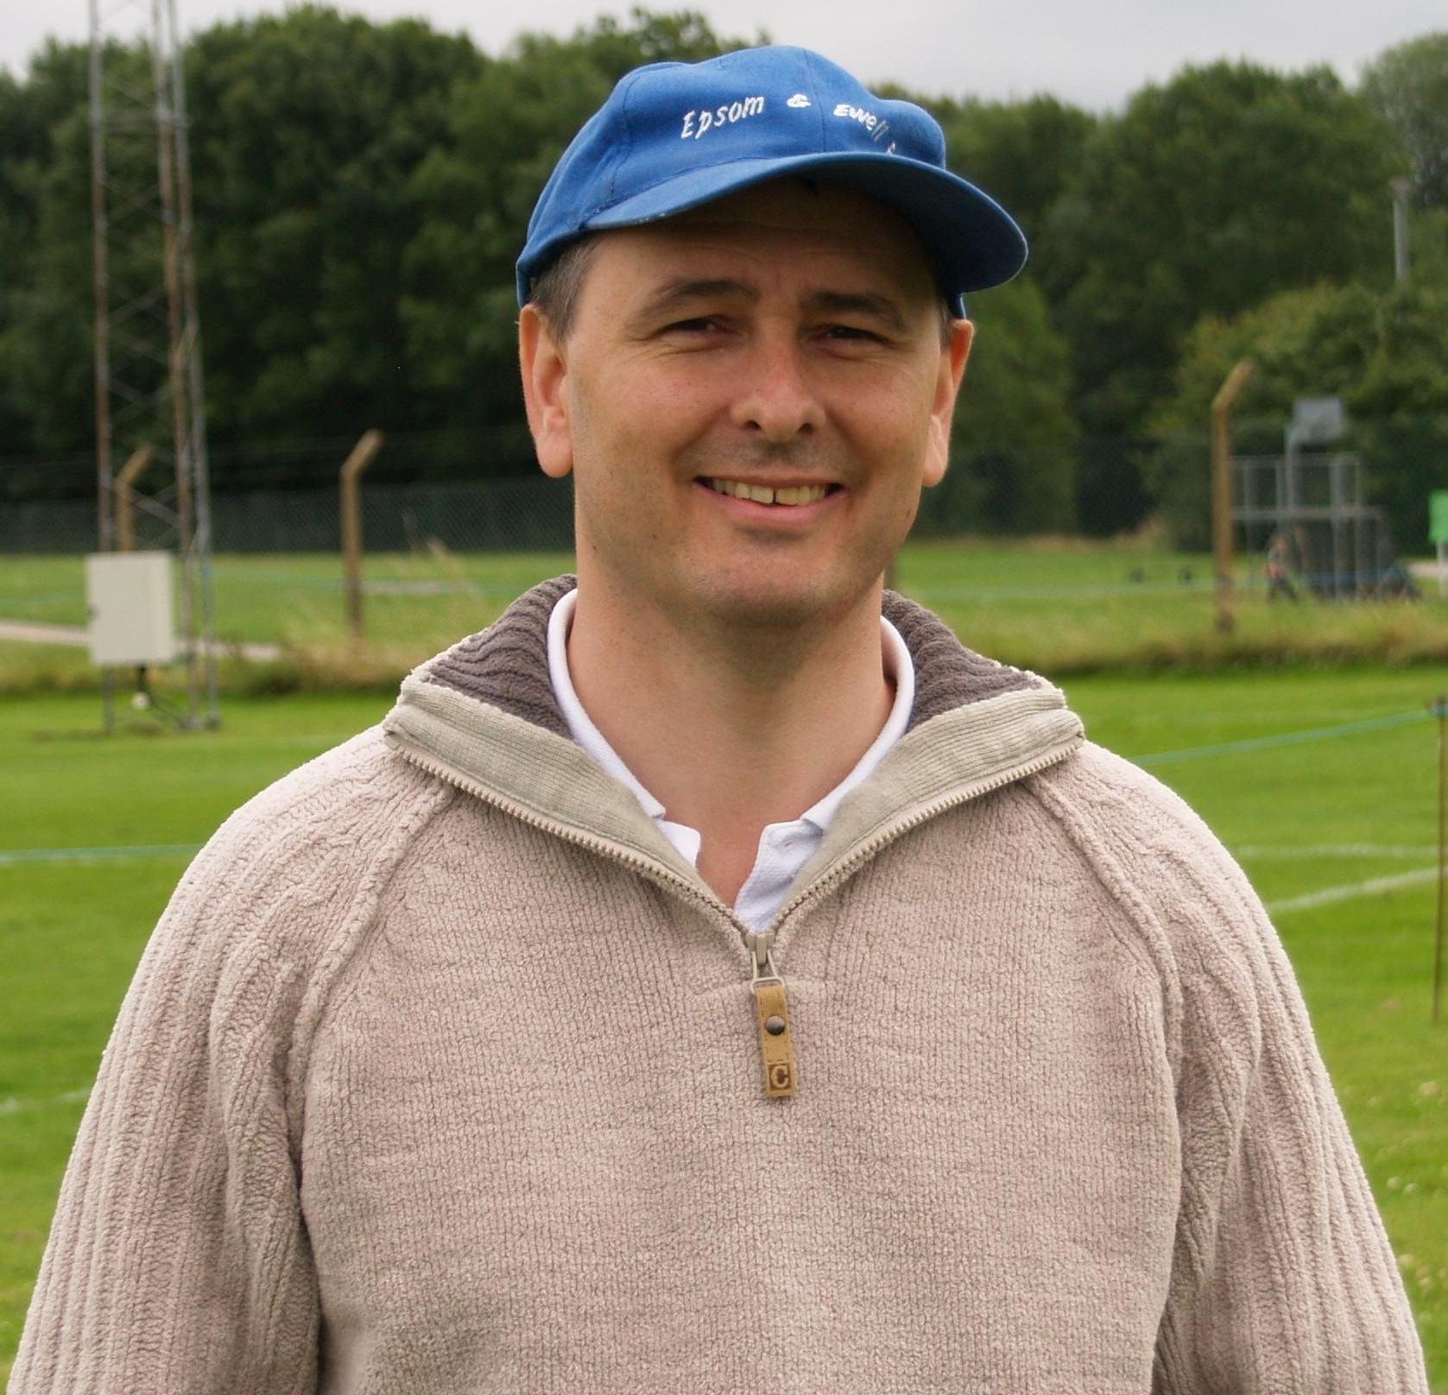
To try and get this list down to 100 has been an extremely difficult task. Occasionally I have put matches together for obvious reasons, as you’ll find out over the course of the season, and by the end of the season, we’ll find out which was top of the list.

61 – Epsom F.C. 9-1 Camberley Town - Surrey Senior Cup First Round
Saturday 3rd January 1953

Camberley Town were not the greatest of sides back then, but if you could walk away from a 9-1 win and say it wasn’t memorable, then I’d be very surprised!

Back then we were having a great season anyway, eventually finishing in our highest ever Corinthian League position of third, and Bill Goddard had already scored 32 goals in just 19 games, and he got another five here, eventually finishing on 54 for the season, an Epsom post war seasonal record.

Oddly, Epsom did not score for the first 25 minutes of the match, but once they had, Goddard scored a hat trick in five minutes and four goals in nine minutes with the visitors scoring an 85th minute consolation goal.

60 – Epsom F.C. 9-0 Dorking - Corinthian League
Wednesday 26th December 1956

Happy Christmas! At least it was for Epsom F.C. as Dorking made their first League visit to Epsom since Christmas Day 1926. Even though they were technically League equals, this was a no contest, and the Dorking & Leatherhead Advertiser said it may have been Dorking’s worst ever defeat.

On a snow-covered pitch, Johnny Bangs scored four to bring his tally up to thirty, while Dave Hermitage also got a hat trick. When Bangs left the game early due to an injury, he received admiring applause from the Dorking fans, who were probably relieved to see the back of him. This wasn’t strictly true though, as he scored three more in a 4-0 win in the return League fixture at Meadowbank!

59 – Dunkerque 7-0 Epsom F.C. - Friendly - Sunday 5th December 1937

For those who ask me if the Blues have ever played abroad, the answer is yes. However, I have traced no reason why the Blues played a London League match on the Saturday, winning 10-1, and then most of them getting on a boat to France that evening. It was a rough crossing, and Epsom were “hopelessly outplayed” by the professional outfit.

They were treated well, and greeted by the President of the French Football Federation, and the French side were invited to return, but the impending war situation was probably the reason that this never happened.

58 – Enfield 5-0 Epsom & Ewell - F.A.Cup Fourth Qualifying Round
Saturday 1st November 1980

Thirty years ago Epsom & Ewell were very good. They were arguably playing at the highest level they had ever done, and were to defeat Sutton United and draw twice with Bishops Stortford, who happened to be the two F.A.Trophy Finalists that season.

However, there was good, and there was very good. Enfield were a superb team, and for Epsom’s first appearance in the Final Qualifying Round of the F.A.Cup for 47 years they couldn’t have drawn anyone tougher.

The Blues were crushed at this stage and missed out on a fairly easy home tie against Wembley in the First Round. Meanwhile Enfield marched on, defeated Hereford United and then Port Vale after a replay, before Barnsley ended the run in the Fourth Round at White Hart Lane, again after a 1-1 draw at Oakwell. So Epsom’s loss was no disgrace. Like I say, we were a good team back then.

57 – Epsom & Ewell 4-0 Windsor & Eton - Isthmian League Division One
Saturday 11th February 1984

Windsor & Eton were the best team in Epsom’s division this season, and had reached the Second Round Proper in the F.A.Cup, losing a replay to Harry Redknapp’s Bournemouth, with a home tie against Manchester United waiting for them, which the South Coast side won. So if Windsor & Eton were as good as Bournemouth who were better than Manchester United, then where does that place this result?

A Steve Hill hat trick was my overriding memory of this one. Well it was, once I had sobered up, as I’d been to a great party the night before, which had only finished at 9 a.m. that morning. We were all young once, you know!

The players celebrated like we’d won promotion, and three months on, that’s what happened, as we clinched the runners-up spot behind the Geoff Chapple inspired Windsor, and both went up into the Isthmian League Premier Division for the first time.

56 – Hertford Town 2-4 Epsom & Ewell - Athenian League Division One
Saturday 1st May 1965

This match was memorable for all the wrong reasons, despite winning the game itself.

Epsom & Ewell were desperate to avoid relegation for the first time in their history, having been reprieved the year before when no clubs were relegated. This time, one club would definitely be dropping so we needed to win this last match to send Dorking down instead.

Epsom’s game took place at 6 p.m. following the F.A.Cup Final, which was being televised, and the Blues seemed to have prepared well. They signed five Tooting & Mitcham players on, which they could do as their Isthmian League season was finished.

Maybe not surprisingly they won the match 4-2, but a Dorking official was at the match, and spotted an ineligible player Maurice Griffiths playing under the name of Chris O’Mahoney, providing a picture of the offending player in Epsom colours.

Maybe the picture came from another game when Griffiths had previously been ineligible, but I don’t understand why we would go to the trouble of registering five new players, only to play someone else who wasn’t. Either way, the club were found guilty, fined £5 and five shillings, lost the two points for the game and went down. A sad episode in the club’s history.

Southern Youth League Cup
First Round
Sandhurst Town | 0-3 | Oakwood
Crawley Down | 28/10 | Lewisham Borough
Godalming Town | 1-3 | Croydon Athletic
Hartley Wintney | 27/10 | Redhill
Second Round
Epsom & Ewell | 22/11 | Merstham
Cobham | 25/11 | Guildford City
Leatherhead | 22/11 | Lingfield
Fleet Spurs | 24/11 | Croydon Athletic
Chessington & Hook United | 24/11 | Crawley Down /  Lewisham Borough
Three Bridges | V | Oakwood
East Grinstead Town | V | Hanworth Villa
Colliers Wood United | 25/11 | Cranleigh
Hartley Wintney / Redhill | V | Croydon
Westfield | 24/11 | Horley Town
Dorking | V | Camberley Town
South Park | 25/11 | Egham Town
Tooting & Mitcham United | V | Ash United
Molesey | 24/11 | Balham Blazers
St Andrews | 18/11 | Bedfont Sports
Cove | 24/11 | Chertsey Town
Third Round
Leatherhead / Lingfield | V | Chessington & Hook / Crawley Down / Lewisham Borough
Dorking / Camberley Town | V | Molesey / Balham Blazers
Three Bridges / Oakwood | V | Cove / Chertsey Town
St Andrews / Bedfont Sports | V | Fleet Spurs / Croydon Athletic
Tooting & Mitcham Utd / Ash Utd | V | Westfield / Horley Town
Colliers Wood Utd / Cranleigh | V | Cobham / Guildford City
East Grinstead Town /  Hanworth Villa | V | Epsom & Ewell / Merstham
Hartley Wintney / Redhill / Croydon | V | South Park / Egham Town

Youth Team Fixtures 2010/11
All HOME fixtures are to be played at Grand Drive Raynes Park Vale F.C.
1 | 01/09/10 | Wed | Westfield | SYL | 1-2 | Banks (pen)
2 | 06/09/10 | Mon | CHICHESTER CITY | FAYC | 2-1+ | D.Smith, Panayi
3 | 13/09/10 | Mon | Chessington & Hook United | SYL | 4-1 | Nevin (2), Banks, Henry
4 | 16/09/10 | Thur | Balham Blazers | SYL | 1-3 | Tchetche-Santacreu
5 | 20/09/10 | Mon | LANCING | FAYC | 0-5
6 | 27/09/10 | Mon | COBHAM | SYL | 3-2
7 | 06/10/10 | Wed | Chertsey Town | SYL | 3-5 | Beenham, Nadesan (2)
8 | 14/10/10 | Thur | South Park | SMFC 1 | 0-3
9 | 20/10/10 | Wed | Lewisham Borough | SYL |  | @ Ladywell Arena
 |  |  | Dorking | GM 1
 | 22/11/10 |  | MERSTHAM | SYLC 2
SYL - Southern Youth League, FAYC - F.A.Youth Cup, GM - Grant McLellan Youth Cup
SYLC - Southern Youth League Cup, SMFC - Surrey Midweek Floodlit Cup

Southern Youth League Table

inc Saturday 16th October | P | W | D | L | F | A | Pts | GD
Chertsey Town | 6 | 5 | 0 | 1 | 26 | 8 | 15 | +18
Westfield | 6 | 3 | 1 | 2 | 13 | 7 | 10 | +6
Tooting & Mitcham Utd | 5 | 3 | 1 | 1 | 18 | 15 | 10 | +3
Molesey | 6 | 3 | 1 | 2 | 14 | 12 | 10 | +2
Croydon | 6 | 2 | 2 | 2 | 16 | 14 | 8 | +2
Balham Blazers | 5 | 2 | 2 | 1 | 14 | 13 | 8 | +1
Colliers Wood Utd | 3 | 2 | 1 | 0 | 13 | 5 | 7 | +8
Epsom & Ewell | 5 | 2 | 0 | 3 | 12 | 13 | 6 | -1
Cobham | 4 | 1 | 1 | 2 | 8 | 7 | 4 | +1
St. Andrews | 6 | 0 | 4 | 2 | 7 | 12 | 4 | -5
Chessington & Hook Utd | 5 | 0 | 2 | 3 | 5 | 20 | 2 | -15
Lewisham Borough | 5 | 0 | 1 | 4 | 4 | 24 | 1 | -20

2nd XI Fixtures 2010/11
All HOME fixtures are to be played at Grand Drive, Raynes Park Vale F.C.
1 | 28/08/10 | Sat | East Grinstead Town | SL | 3-2
2 | 04/09/10 | Sat | Whitehawk | SL | 0-2
3 | 13/09/10 | Mon | Redhill | SL | 1-0
4 | 18/09/10 | Sat | Three Bridges | SLC 1 | 4-1
5 | 25/09/10 | Sat | Crawley Down | SL | 1-3
6 | 04/10/10 | Mon | COLLIERS WOOD UTD | SL | 2-3
7 | 09/10/10 | Sat | Lingfield | SL | 4-2
8 | 11/10/10 | Mon | MOLESEY | SL | 5-0
9 | 16/10/10 | Sat | Corinthian Casuals | SL | 0-3
10 | 23/10/10 | Sat | South Park | SL
11 | 25/10/10 | Mon | MERSTHAM | SL
 | 13/11/10 | Sat | Corinthian Casuals | SLC 2
SL - Suburban League SLC - Suburban League Cup

Suburban League South League Table
inc Saturday 16th October | P | W | D | L | F | A | Pts | GD
Corinthian-Casuals | 11 | 9 | 1 | 1 | 26 | 12 | 28 | +14
Banstead Athletic | 13 | 9 | 1 | 3 | 28 | 16 | 28 | +12
Merstham | 9 | 6 | 1 | 2 | 34 | 12 | 19 | +22
Cobham | 11 | 6 | 0 | 5 | 30 | 28 | 18 | +2
Colliers Wood Utd | 12 | 5 | 3 | 4 | 22 | 24 | 18 | -2
Chipstead | 11 | 5 | 2 | 4 | 35 | 23 | 17 | +12
Chessington & Hook United | 11 | 5 | 2 | 4 | 26 | 23 | 17 | +3
Crowborough Athletic | 10 | 5 | 2 | 3 | 18 | 20 | 17 | -2
Lingfield | 9 | 5 | 1 | 3 | 30 | 15 | 16 | +15
Whitehawk | 9 | 5 | 1 | 3 | 26 | 16 | 16 | +10
South Park | 12 | 4 | 3 | 5 | 23 | 21 | 15 | +2
Crawley Down | 9 | 4 | 2 | 3 | 18 | 16 | 14 | +2
Corinthian | 9 | 4 | 1 | 4 | 21 | 14 | 13 | +7
Molesey | 11 | 4 | 1 | 6 | 21 | 27 | 13 | -6
Epsom & Ewell | 8 | 4 | 0 | 4 | 16 | 15 | 12 | +1
East Grinstead Town | 10 | 3 | 2 | 5 | 16 | 17 | 11 | -1
Redhill | 11 | 3 | 0 | 8 | 18 | 24 | 9 | -6
Oakwood | 10 | 1 | 0 | 9 | 9 | 52 | 3 | -43
Horley Town | 12 | 0 | 1 | 11 | 8 | 50 | 1 | -42

Suburban League Cup
First Round Draw
Leatherhead | 23/10 | Oakwood
Chipstead | 1-1+ | Lingfield
Chipstead won 6-5 on penalties
Fleet Town | 5-3 | Sandhurst Town
Northwood | 1-0 | Barton Rovers
Harefield United | 0-1 | Beaconsfield Sycob
Chalfont St Peter | 3-1 | Boreham Wood
Corinthian | 2-2+ | Merstham
Corinthian won 4-3 on penalties
Leverstock Green | 3-4 | Met Poilce
Whitehawk | 2-4 | Tooting & Mitcham United
Redhill | 3-1 | Colliers Wood United
Three Bridges | 1-4 | Epsom & Ewell
Corinthian Casuals | 3-1 | Banstead Athletic
Tring Athletic | 4-1 | Molesey
Eastleigh | 1-6 | Camberley Town
Cove | 0-3 | Cobham
Newport Pagnell Town | 3-1 | Hartley Wintney
Berkhamsted | 0-2 | Chesham United
Tonbridge Angels | 23/10 | Horley Town
Chessington & Hook United | 5-0 | Hanworth Villa
Carshalton Athletic | 3-2 | Bedfont Town
Crawley Down | 0-2 | Crowborough Athletic
North Greenford United | 1-4 | A.F.C. Hayes
Second Round Draw
Corinthian Casuals | 13/11 | Epsom & Ewell
Tooting & Mitcham United | 13/11 | Leatherhead / Oakwood
A.F.C.Hayes | 23/10 | Northwood
Fleet Town | 6/11 | Chessington & Hook United
Met Police | 27/11 | Leighton Toiwn
Chesham United | 23/10 | Beaconsfield Sycob
Redhill | 6/11 | Woking
A.F.C.Wimbledon | 23/10 | East Grinstead Town
Hampton & Richmond Borough | 6/11 | Carshalton Athletic
Crowborough Athletic | 27/11 | Sutton United
South Park | 6/11 | Corinthian
Camberley Town | 23/10 | Chalfont St Peter
Uxbridge | 13/11 | Newport Pagnell Town
Tonbridge Angels / Horley Town | V | Cobham
Chipstead | 13/11 | Eastbourne Borough
Tring Athletic | 30/10 | Hemel Hempstead Town

Reserves Report
Epsom & Ewell Reserves 5-0 Molesey Reserves – Monday 11th October – by Robert Oakes

The deadlock was broken on 13 minutes as Alex McGregor’s threaded pass cut the Molesey defence open allowing former Leatherhead striker Dave Stevens to run on to the ball and fire low past the advancing Moles’ keeper from just inside the visitors box. Epsom buoyed by taking the lead came into the match and were soon creating problems for the visiting defence, Dave Stevens collecting a floated cross field ball by Daniel Cormack on 20 minutes, the lay back by Stevens finding Lee Binns but his effort was deflected wide for an Epsom corner. The resulting Matt Chapman corner was headed on to his own crossbar by a Molesey defender.

Hesitant defending by Epsom on 26 minutes allowed the visitors to work a good move down their left wing, the ball being allowed to be squared across the face of the home box for a Molesey midfielder to curl an effort towards the top corner but Jack Witts was equal to the effort as he acrobatically pushed the ball away from his goal – the save just as good as Paul Borg’s during Saturday’s first team encounter between the clubs.

Epsom should have been two up on 31 minutes as midfielder Alex McGregor slipped the ball into Lee Binns, the E’s striker taking the ball around the back of the Moles’ defence but his effort from 10 yards out could only find the side netting. The final ten minutes were mainly Molesey as the visitors won a couple of corners without really troubling Jack Witts - the keeper being called into action only once during the first minute of injury time as he was forced to tip a close range header over his bar.

The lead was doubled within 45 seconds of the second half starting. Matt Chapman’s floated ball going over the two Molesey defenders that jumped to try to head the ball clear which allowed the ball to find Dave Stevens unmarked at the back post to bring the ball down with his in-step and then in the same movement execute a powerful half volley into the roof of the net from 8 yards out. Dave Stevens two minutes later was denied his hat-trick by the flag of the assistant referee, Daniel Cormack had rolled the ball through for Stevens to latch on to and hit a first time effort from 30 yards out that sailed comfortably past the visitors keeper’s dive – the ball ending up nestled in the bottom corner but the flag was raised a second after Stevens had executed his effort.

Epsom’s defence was caught napping on 67 minutes as a rare Molesey attack saw the visitors break the Epsom defensive line, the Molesey player appearing to be bearing down on the Epsom goal but youth centre-back Marcus Lovett managed to get back as he managed to get his legs in the way of the attempted shot from 12 yards to deflect the ball out for a Molesey corner.

Epsom had been relatively quiet for around 20 minutes before the third goal occurred on 72 minutes, Lester Boniface replaced Lee Binns and it was Boniface that turned provider. He challenged for the ball just inside the Molesey half and close to the right bye line, the strength of Boniface allowed him to get the better of the visiting midfielder, with space and time he floated a 30 yard cross field ball into the box finding an unmarked Dave Stevens arriving into the Molesey box to perform an aerial bicycle kick volley from 15 yards out that flew straight through the keeper.

We then went on the rampage, as the visitors could not handle the home side. Marcus Lovett started the move that resulted in Epsom & Ewell fourth on 75 minutes, Lovett’s cross field ball finding Alex McGregor who exchanged passes with Max Smith before flicking the ball into the path of Dave Stevens inside the penalty area who back heeled the ball on to Lester Boniface to execute an angled finish into the far corner of the net from 10 yards out.

Boniface’s persistence saw him steal the ball away from a Moles’ defender within the away box on 82 minutes, his lay back across the face of the six yard box saw the visiting keeper unable to reach the ball but it was also just too far out of the reach of Dave Stevens boot – had his boot been two inches longer it would have been five and four for Stevens. The wait for a fifth had to only last another sixty seconds as Lester Boniface picked up the ball just outside the box as he made a solo mazy run into the box evading the challenges of the four Molesey players in his way before finishing with a powerful angled shot from 12 yards out into the opposite corner to where he put his first.

In the second minute of injury time a ball over the now disorganised Molesey defence allowed Dave Stevens to collect and bring the ball in towards the goal, instead of going for his fourth he tried to square the ball trying to get the unmarked Boniface a deserved quick fire hat-trick, but the covering Molesey defender managed to get in the way of the pass to deflect the ball out for a corner.

Our new Website
Do you like the new website?

Janice Pond has kindly stepped in to facilitate a move to the pitchero group of websites, and as you can see below, it looks very professional.

While our previous website was also good, this has a couple of advantages. Firstly it is a new look, which makes a nice change, and secondly, many people can update it, as access is being granted to all Committee and Playing Management.

To join up, all you have to do is enter the website and then join pitchero as a member (the link is up in the top left corner) and select the club name. From there you’ll be asked which categories of membership you require. Supporter or player would be your first box to tick, but there are other categories too.
Just go to http://www.pitchero.com/clubs/epsomandewellfc/ and you’ll see all of this.
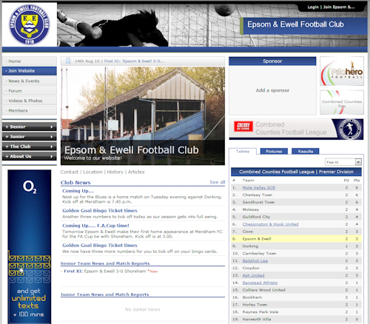

This page for appearances spreadsheet (centre pages)

This page for appearances spreadsheet (centre pages)

Golden Goal Bingo Ticket update
We have now started the second scoring period. Although we failed to score at Badshot Lea, we have scored against Worcester Park, Molesey, and Hanworth Villa, so the numbers are starting to come in. The official times are below.

Date | Comp | Opponents | H/A | F/T | Goal Times
02/10/10 | CCL | Badshot Lea | A | 0-4 | none
05/10/10 | CCLC2 | Worcester Park | H | 2-2 | 54, 92
09/10/10 | CCL | Molesey | H | 2-2 | 58, 89
16/10/10 | CCL | Hanworth Villa | A | 1-0 | 65
19/10/10 | CCL | Ash United | H
23/10/10 | CCL | Badshot Lea | H
30/10/10 | CCL | Colliers Wood Utd | A
06/11/10 | CCL | Raynes Park Vale | H
14/11/10 | CCL | Bracknell Town | H
16/11/10 | CCLC3 | Camberley Town | H
20/11/10 | CCL | Cove | H
27/11/10 | CCL | Ash United | A
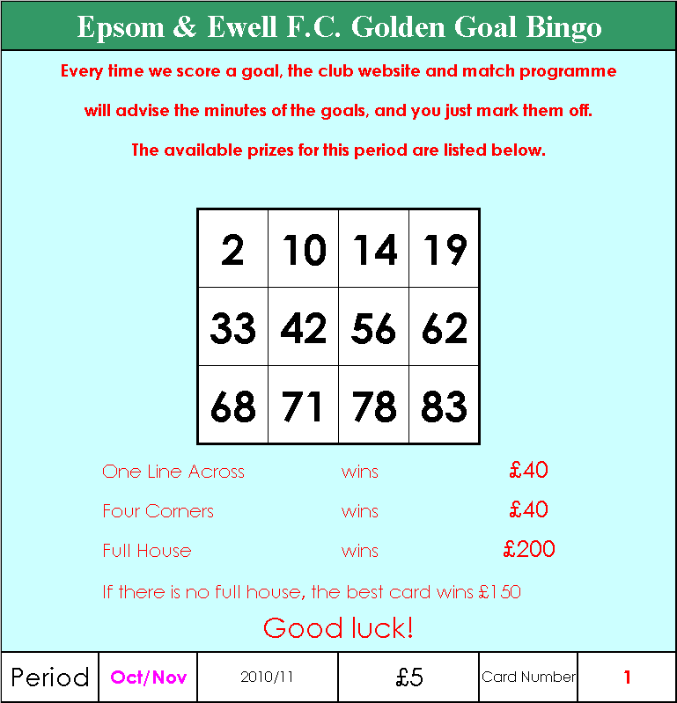
We can announce that we have already sold nearly 170 tickets!!

Please bear in mind that it is down to all supporters out there to sell as many tickets that they can. Not just myself, the two Steve’s and the Chairman.

Even if just ten of you sold ten at work, then that would raise £500 towards the Fund-Raising Exercise.

If you have bought tickets for this period, thank you for your support, and if you want to sell a few to friends and family, just ask.

The Epsom & Ewell F.C. Fund-Raising Thermometer!
We currently sit at £1,425 at present following the launch of the next batch of tickets.

We are now taking orders for a DVD showing the Epsom & Ewell v Aldershot Town match from April 1993. This was the last ever League match played at West Street and gives a great snapshot of what West Street looked like at the end of its life. They are available for £10, so please let me know if you would like a copy.
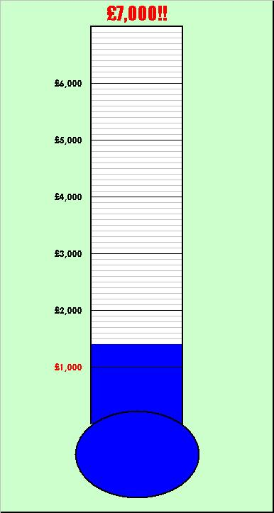

Ash United Club History
Ash United Football Club was founded in 1911 and started playing their first competitive matches at Ash Common. Ash soon became well established in the Surrey Intermediate League, winning every honour possible - they proved that they had a future!

After the Second World War Ash United restructured and in 1947/48 they had the most successful season in their short history, winning the League Championship and four-cup competitions. It was almost twenty years they had to wait until their next successful campaign.

During the 1966/67 season Ash United dominated the Surrey Intermediate Premier "A" League, winning the title with only two points being dropped out of a possible fifty-two. As the points suggest, Ash’s achievements included a long unbeaten record with 121 goals for and only 19 against. Success breeds success, it’s an old adage but nonetheless true, the reserve team also had a terrific season. They won the Division "A" title and scored an amazing 137 goals in only 26 games, an average of 5 per game and some incredible scores. With the first team and the reserves doing well this gave the club a good squad of players, all competing for first team places. In 1968 Ash won promotion to the Surrey Senior League, and in their first season they finished runners up, and also finished as runners-up in the cup.

This successful start in the Surrey Senior League came to an abrupt end in 1971 when Ash were forced to change grounds, this meant they lost their place in the Senior league and had to drop into the Aldershot League. Ash managed to find a new permanent home with the co-operation of the local council at Shawfield Road, which remains their home to date, this meant Ash were re-admitted to the Surrey Senior League.

During the late ‘70’s Ash had several successful seasons, in the 1977/78 season Ash won the Charity Cup defeating Dorking 2-1 in the final, the following season Ash finished runners-up in the newly named Combined Counties League as well as reaching the finals of the Philips Football Floodlighting Competition. It took Ash several years before they managed to win the Combined Counties League, which they eventually won in 1981/82. Ash also finished runners-up in the Concours Trophy and the George Allen Trophy during that year.

The 1984/85 season saw Ash getting through to the quarter finals of the Surrey Senior Cup, as well as being runners-up in the Concours Trophy again. During

the 1985/86 season Ash had a creditable run in the FA Vase, followed by a great league performance in 1986/87. Ash won the League for the second time under the management of Chris Penny.

Ash produced their best run in the FA Vase in 1993/94 by reaching the second round only failing to go further by losing to Littlehampton in a replay. The following few season Ash had trouble keeping a team together and only managed mid-table performances, but despite this lack of success on the pitch the committee and backroom staff continued their hard work in preparing the club for the future. This work has led to a considerable improvement in the facilities at Shawfield Road, most notably was the installation of floodlights for the start of the 1996/97 season and further improvements to the changing rooms, dugouts, and fencing.

The 1997/98 season was Ash United’s best for several years, with the new manager Jamie Horton bringing his considerable experience to good effect. He has brought together a squad of players that won the Challenge Cup and the Fair Play Trophy in his first season as player/manager. The team also created a new league and club record with 29 games unbeaten in league and cup, which included a run of 21 straight wins.

The following season Jamie formed a side that took the League title by a massive 13 points. His team also won the Aldershot Senior Cup beating Fleet Town and reached the last 32 of the FA Vase before losing to the Holders & winners Tiverton Town in front of a record crowd at Shawfield Road.

Jamie Horton had a second stint as manager during the 2001/2002. He then took Ash United to their highest points total for a season when they reached 100 but it still wasn't good enough to take the title and they finished runners-up to AFC Wallingford. They however did regain the Aldershot Senior Cup beating 3 RSME Regiment and also reached the last 32 of the FA Vase before losing to Tow Law Town. There was more silverware for the club as the Reserves won the Division One Title.

The 2004 to 2006 seasons saw ex-Aldershot Town player Stuart Udal take charge of the team. Great progress was made with Ash United finishing 3rd in the League.

After 18 years’ service as a player with Ash United Paul Bonner take over the manager’s position last season with Mattie Everard ably assisting him. They found it hard going at the beginning but slowly but surely they both turned Ash’s fortunes around & by the end of the season were one of the form teams.

On-pitch changes have been augmented with off-pitch changes; a new senior committee has been elected who have a combined vision and commitment to progress Ash United to new levels.

Alan Carter

Combined Counties Premier League Pro XI

Regular readers will know that I’m a bit sad when it comes to compiling lists. This time I’ve produced a list of former pro footballers that once played for a team currently playing in the Combined Counties Premier Division. In my team are four former internationals, a MBE, a UEFA Cup winner and a man with a love of Fedora hats!

GK: Ray Drinkwater - Guildford City

Ray began his career with Guildford City in 1951. He made 109 appearances before joining Portsmouth of the old First Division for £2,000 in 1957. Yet it was with Third Division QPR where Ray had most success making 214 appearances for the West London club before returning to non-league football in 1963.

LB: Darren Barnard - Camberley Town

Current Camberley Town Joint Manager and Director of Football, Darren ended his playing days with the club making 100 appearances between 2007 - 2010. Darren played for a number of professional clubs most notably Chelsea and Barnsley and represented Wales 22 times between 1998 - 2004.

CD: Matt Elliott - Epsom and Ewell

Matt is the first of two former EE’s player in the team. He played for our youth side in 1987-88 before going on to play for six professional teams, most notably Leicester City making 245 appearances between 1997 - 2005. Although born in Wandsworth, Matt played for Scotland 18 times between 1998 - 2001. The highlight of his career was scoring both goals for Leicester in their League Cup final victory in 2000.

CD: Nigel Smith - Banstead Athletic

Banstead born centre defender Nigel left his home town team in 1974 to join 4th Division Brentford. He played 85 times for “the Bees” and returned to non-league football with the Met Police in 1979.

RB: Gary Peters - Guildford City

Gary began his career at Guildford City before moving to Fourth Division Reading in 1975, winning promotion to Division 3. He made a total of 431 professional appearances for 4 clubs. In 1994 Gary became manager of Preston North End and later managed Exeter City and Shrewsbury.

LW: Terry Dyson - Guildford City

Terry was a regular member of Tottenham Hotspur’s 1961 League & Cup Double winning side scoring in the 1961 FA Cup Final. He also scored twice in Spurs 1963 UEFA Cup victory over Athletico Madrid. Terry made 209 appearances for Spurs scoring 55 goals, including a hatrick against Arsenal. He finished his playing career with Guildford City in the early 70’s after spells with Fulham and Colchester United, and then was

Manager of Boreham Wood when they played us in the early eighties.

CM: Alan Pardew - Epsom & Ewell

Alan played in Midfield for the EE’s whilst working as a glazier and part-time cab driver at the beginning of his career. He stayed in non-league until he joined 2nd Division Crystal Palace aged 25 in 1987. Alan is now a high profile manager and has reached the FA Cup Final twice, as a player with Palace in 1990 and as a manager with West Ham in 2006, losing on both occasions. Alan has won promotion three times in his career, as a player with Palace and as a manager with Reading and West Ham.

CM: David Howells - Guildford City

David was involved with his hometown club as Director of Football and occasional player at the beginning of the “noughties“. He made his name at Tottenham Hotspur making 335 appearance between 1985-1998, winning the 1991 FA Cup.

RW: Archie Turner - Camberley Town

At the start of his playing career Arthur “Archie” Turner, played Outside Right for Camberley. Archie represented England in 1900 and 1901 and played in the 1900 and 1902 FA Cup Finals for Southampton, losing on both occasions.

CF: Cyrille Regis MBE - Molesey

Cyrille began his playing career with Molesey in season 1975-76, scoring 25 goals. Regis went onto play for 6 professional clubs including West Brom (301 appearances - 112 goals) and Coventry City (274 appearances - 62 goals). Cyrille’s career highlight was winning the 1987 FA Cup final. Cyrille played 5 times for England between 1982 and 1987 and was made a MBE in 2008 for services to football and charity.

CF: Giuliano Grazioli - Wembley FC

Giuliani played for Wembley in 1995 before making his name at Stevenage Borough. He scored in their FA Cup 4th round tie against Newcastle in 1998 forcing a replay. This exposure enabled him to turn professional and he had spells at Bristol Rovers, Swindon Town and Peterborough United. He retired after a spell with Dover Athletic in 2009.

Manager: Malcolm Allison - Wembley FC

Malcolm Allison played 238 times for West Ham between 1951 - 1957 but is best known as a manager. With Joe Mercer, Allison helped transform then 2nd Division Manchester City, winning seven trophies between 1965 and 1973. However, it was Wembley FC who gave Malcolm his first job in football management in 1962-63. Allison was also famous for his outspoken nature, controversies off the pitch and his Fedora hat and cigar.

(Note from Ed: Alan must be psychic, as he selected Malcolm Allison when he wrote this article a week or two back, before his recent death aged 83.)

If you know of any ex professional players who have played for a current Combined Counties Premier League team and who are not in my team please let me know. I’ve posted a message on our website looking for more players with the hope of putting together another team to take on my “original eleven”.

Steve Dyke
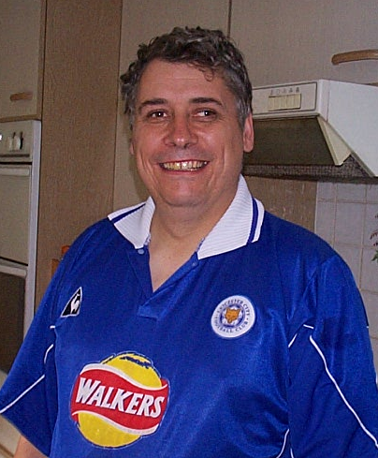
The Chilean Miners (and gopak tables)

“Chi Chi Chi Le Le Le, los mineros de Chile” has to win chant of the week award… on any other week “2-2 to the referee” would have scooped the prize.
Still the rescue of the 33 has been the best good news story of the week and a global phenomenon, the only thing I could compare it to was the moon landings which I have faint memories of from my childhood.

I got right into it, as you can gather, and the reason was my own fault and a rather lesser tale of Health and Safety failings of its own. On Tuesday night I was packing away the tables at Tuesday Club; an operation I have carried out successfully pretty much every Tuesday night for the last 20 + years.

I ended up having a bit of a Stan from Dinner Ladies moment, as I had no other male volunteers present. Also I wanted to get stuff done quickly to listen to the end of the England match in the car on the way home. Watching women putting away gopak tables can be a painful experience - firstly they consider it to be a two person job – one on each end – which cannot be completed without a couple of minutes of “ooh these things are really stiff” and “I can’t shift them”.

I on the other hand am a dab hand at the leg-leg, lift-and-go school. I’m confident in my technique and often make comments about having one of them down and away in 9 seconds like the Ferrari pits. On Tuesday night I became too confident.

Partly because others were chatting and not really helping I really wanted to demonstrate how quickly it could be done. Pinging the first leg back whilst in mid air without grounding the table was perhaps too cavalier a move – the matador of the gopak table - I was perhaps hoping to complete the manoeuvre with an “ole”.

The table slipped from my grasp and landed on my big toe. Agony.

So it was I spent a long Tuesday night awake in front of rolling news; paracetemol alone incapable of numbing the pain. But what drama had been laid on for me! It was also one good for putting my minor problems into perspective. By Wednesday stronger painkillers having been obtained - and I always feel better if I can enter he GP’s room with a distinct limp on – I had got so into the rescues even though knackered I stayed up until 2 am to see number 33 come out. It had to be done – it was a great moment as I hopped round the front room punching the air.

It was a great news story for so many reasons. The courage and fortitude of the trapped miners in extreme circumstances was amazing. Their story also showed that

getting the raw materials for the economy involves someone a long way away doing a dangerous job.

As they came out the miners all showed the power of their love for their nearest and dearest in the emotional scenes we have seen on all the news bulletins. There were two other ways that the escapes were generally marked … some of the miners showed the Christian faith which had sustained them through their ordeal by publicly praying and others were presented with mementos and shirts from their favourite football teams – some did both. The ex footballer Franklin Lobos even did a bit of keepy-uppy to show how fit he was.

As a fervent football fan that is also a Christian, I am sometimes troubled by this religion and football parallel because it does seem we sometimes do take our football too seriously. The parallel saga of the week of the ownership of Liverpool shows the passion and depth of feeling the game can arouse.

Passion is an interesting word. It’s something we as fans think we give ourselves and we demand it of players, managers and club owners. When large money comes into it as in the premier league it arouses more ire if sufficient passion is not displayed, yet we still demand a level of commitment from our small money players when we have paid only £ 6.

In its strictly religious meaning the word passion refers to the crucifixion of Christ and the events leading up to it. I’m sure we wouldn’t demand that much of our teams but you will often hear people exhorting teams to shed blood, sweat and tears or run through brick walls for the cause. The miners’ faith certainly seems to have helped keep them together and certainly if living in a confined space with a group of people you haven’t chosen, a certain level of forgiveness will be necessary.

One conclusion I have drawn from the experience is that I would not want to be sharing a cave with Professor Richard Dawkins for a sustained spell of time.

The Molesey game showed us all something too. They were understandably fuming at the turn of events and several vented their spleen at the ref at the end. I personally have been that person when it’s been the other way round and I’ve let myself down on those occasions by letting my misguided passion run away with me. I’m now much easier on referees and we sure can’t moan about any decisions going against us for a while. (Yeah, right! – Ed)

One thing is that our performance last Saturday was poor - apart from Borgy who kept the score down to a level that the ref could influence the game - and we deserved to lose. When we beat Dorking 5-0 I became over confident and stated we were playing so well we might do that to a few teams this season… the dangers of overconfidence. Now where is that accident form,….

Steve Davies

Taking Stock

We are now pretty much one third of the way through our league program for this season so I thought I would take a look and see how we are measuring up to last year, by doing a quick comparison between this season and 2009/10.

Looking at the league table our form is very predictable. We have taken maximum points in the five games against teams below us in the league; we have drawn both games against teams just above us, and lost all six games to teams in the top nine of the division.

For purposes of comparison I have substituted Bedfont, who are no longer in existence with Mole Valley SCR who were promoted to the Premier division this year. As our division is one team short this year there is no replacement for last season’s champions North Greenford Utd.

Out of the 11 games played in both seasons a “repeat” has occurred on six occasions.

There are four clubs that we have taken six out of six points from (Wembley, Croydon, Hanworth Villa and Banstead) from both fixtures over the two seasons but on the down side we have lost twice at Krooner Park and twice at Badshot Lea.

Overall, against common opponents we are nine points worse off this season than last, which is mainly accounted for by our losses at highflying Egham and Sandhurst and our collapse at home to Guildford, which were all fixtures where we picked up maximum points last season.

We are top heavy on away games so far this term, having travelled on eight occasions against only five run outs at Moatside, and it was always going to be difficult to emulate 2009/10 as in that season we amassed 16 out of a possible 24 points from those away fixtures.

It is also disappointing that our Moatside record is worse than our Merland rise record by two points and I fully expect that to improve, but it cannot tonight as we registered three points and five goals in the home fixture against tonight’s opponents Ash United last season.

 | 09/10 season |  | 10/11 season
Opponents | Home | Away | Home | Away | Difference
Sandhurst Town |  | W |  | L | -3
Croydon |  | W |  | W | 0
Dorking | D |  | W |  | +2
Bedfont / Mole Valley SCR | W |  | D |  | -2
Chessington & Hook Utd |  | D |  | L | -1
Egham Town |  | W |  | L | -3
Banstead Athletic | W |  | W |  | 0
Guildford City | W |  | L |  | -3
Camberley Town |  | L |  | L | 0
Wembley |  | W |  | W | 0
Badshot Lea |  | L |  | L | 0
Molesey | L |  | D |  | +1
Hanworth Villa |  | W |  | W | 0

Total Points Gained | 10 | 16 | 8 | 9 | -9

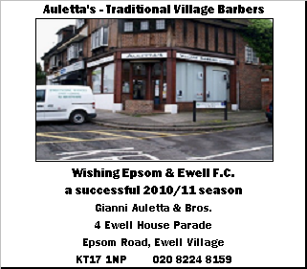

Every Opponent A-Z
Over the years we have played many, many different opponents. Exactly how many is a difficult question, as it all depends on your definition. Are Camberley and Yorktown different to Camberley Town, or are Epsom Town different to Epsom F.C. or Epsom & Ewell F.C.?

In my analysis I have classed them as the same team, and will work through them all from A to Z. Some we have played many times, whilst others maybe just once or twice. Enjoy!
-----------------------------------------------------------------------------------

Bedfont: - Played 10 - W7, D2, L1 - F21, A14 - Points per Game - 2.30 - Fantastic

Before their demise last season, matches against Bedfont were often incident packed, and usually positive.

The first time we met was in an F.A.Cup tie in 2001 when we produced one of the worst ever performances in club history, losing 5-0 in a season when we would ironically earn promotion.

We didn’t meet again until we transferred into the Combined Counties League, since when we have played nine more times. We have led 2-0 only to draw at the Orchard, and have also come back from two goals down to retrieve a draw there too.

We have had referees trying to remove half a dozen of us from behind the goal for some obscure reason, and we have had funny matches, like a 5-1 win at Merland Rise where we kept up much banter with their unpleasant keeper, and also had two penalties scored by Kyle, and a penalty saved by Borgy at the other end.

Finally, we had an abandoned match that was called off with just two minutes remaining with us two – one up. Fortunately, we won the replayed match 2-1 as well and won 4-2 over there for good measure!

Bedfont Green: - Played 7 - W2, D0, L5 - F7, A11 - Points per Game - 0.86 - Awful

Our record against the other Bedfont side is less impressive. We only met them following our transfer to the Combined Counties League, and we won 1-0 in our first meeting.

Since then, it hasn’t been so good. We lost on their own pitch, the old Viking Sports Ground on the A40, although the following year we did win a League match at Yeading’s Beaconsfield Road ground. However, we couldn’t win again at home, losing twice by two goals to one after going into the game on good unbeaten runs, while they also inflicted a 1-0 defeat on us in the Quarter Final of the League Cup in 2007/08.

They have ground shared at Yeading, and latterly Windsor, but are now one of the two sides that reside at the Orchard, following the original Bedfont club’s closure.

Bedford Town: - Played 4 - W0, D0, L4 - F1, A7 - Points per Game - 0.00

Bedford Town were reformed after folding in the early eighties, and losing their famous Southern League stadium, The Eyrie. We then played on four occasions, losing home and away in the League before they were promoted, and more importantly losing 2-0 in the Final of the Associate Members Trophy at Hendon’s old Claremont Road ground.

We had defeated four sides from the division above us to reach the final, but Bedford just had too much, although I recall we struck the woodwork a few times. Finally, we lost narrowly there in the League Cup in a match where we did everything but score. A bit like the earlier matches in all fairness.

Bedford Town Reserves: - Played 7 - W2, D0, L5 - F14, A22
Points per Game - 0.86 - Awful

I have referred to their old Southern League team, but back in the forties we played in the London League with their Reserves. Even then we didn’t do that well!

Although we won our first ever match against them by five goals to three at West Street on 9th November 1946, and defeated them 5-1 two seasons later, we never won in four trips to the Eyrie, losing three times in the League, and also 2-1 in the League Cup in August 1948 in front of 2,500. This was their Reserve team, remember!
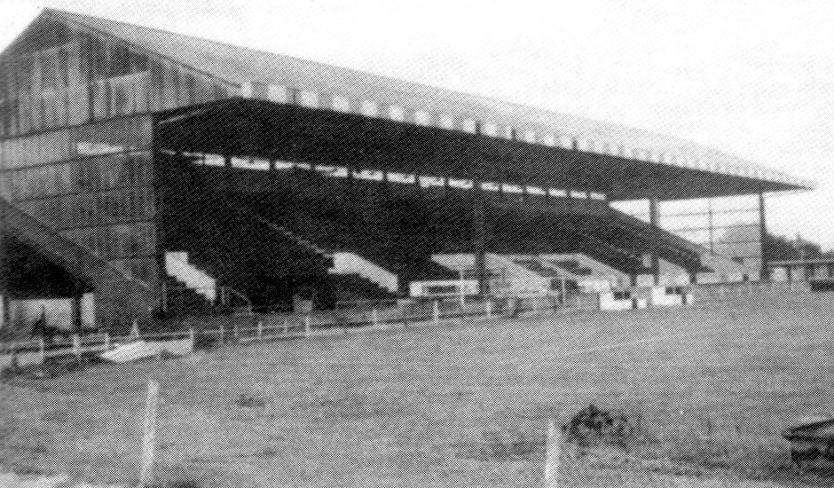
The Old Eyrie – demolished soon after the club folded in 1982.

Berkhamsted Town: - Played 3 - W3, D0, L0 - F8, A5 - Points per Game - 3.00 - Perfect

We first met Berkhamsted Town in 1965/66 following our relegation into the Athenian League Division Two. Goals from Jimmy Wand and Peter Deadman secured a 2-1 win at the old Lower Kings Road ground in September 1965, and the Blues recorded a League double by four goals to three at West Street the following February.

The club had troubles, and disappeared from the scene for a while. By the time we met them again, for a League Cup tie in 1988, the ground had changed beyond recognition, and the reduced site was named Broadwater. We won that evening by two goals to one after extra time after trailing at half time, thanks to goals from Carlton Walcott and Marc Flemington, and never met them again.

The club folded again a couple of years back, but reformed again this year and are back at Broadwater, playing in the South Midlands League Division One (Step Six), with their Reserves back in the Suburban League.

EL Records Combined Counties League Cup
First Round
Badshot Lea |  | 5-1 | Chobham
Banstead Athletic |  | 2-1 | Hayes Gate
Chessington & Hook United |  | 0-2 | Hanworth Villa
Colliers Wood United |  | 2-4 | Egham Town
Cove |  | 1-2 | Epsom & Ewell
Horley Town |  | 3-2 | Eversley
Knaphill |  | 1-3+ | Molesey
Mole Valley SCR |  | 6-1 | Sheerwater
Sandhurst Town |  | 2-0 | Chertsey Town
Second Round
Badshot Lea |  | 0-1 | Croydon
Banstead Athletic |  | 3-4 | Bedfont Sports
Bookham |  | 16/11 | Hartley Wintney
Camberley Town |  | 2-0 | CB Hounslow United
Egham Town |  | 3-1 | Hanworth Villa
Epsom & Ewell |  | 2-2+ | Worcester Park
Epsom & Ewell won 5-3 on penalties
 |  | Bye | Guildford City (Croydon Municipal w/d)
Farleigh Rovers |  | 6/11 | Cobham
Farnham Town |  | 3-0 | Feltham
Frimley Green |  | 2-3 | Staines Lammas
Horley Town |  | 1-3 | Wembley
Mole Valley SCR |  | 3-2 | Westfield
Raynes Park Vale |  | 7-0 | Farnborough North End
Sandhurst Town |  | 7-0 | Dorking
South Park |  | 3-1+ | Ash United
Warlingham |  | V | Molesey
Third Round Draw
Croydon |  | V | Wembley
Epsom & Ewell |  | V | Camberley Town
Mole Valley SCR |  | V | Bookham / Hartley Wintney
Bedfont Sports |  | V | Farnham Town
Raynes Park Vale |  | V | Farleigh Rovers / Cobham
Warlingham / Molesey |  | V | Guildford City
South Park |  | V | Sandhurst Town
Egham Town |  | V | Staines Lammas
Surrey Senior Cup
First Round Draw
Banstead Athletic |  | 19/10 | Whyteleafe
Lingfield |  | 26/10 | Colliers Wood United
Molesey |  | 19/10 | Camberley Town
Dorking |  | 26/10 | Bookham
Walton & Hersham |  | 19/10 | Merstham
Second Round Draw
Chertsey Town |  | 1 | Tooting & Mitcham United
Lingfield /  Colliers Wood United |  | 2 | A.F.C.Wimbledon
Walton Casuals |  | 6/12 | Guildford City
Dorking / Bookham |  | 4 | Croydon
Ashford Town (Mx) |  | 14/12 | Chipstead
Raynes Park Vale |  | 6 | Horley Town
Ash United |  | 7 | Crystal Palace
Redhill |  | 8 | Carshalton Athletic
Chessington & Hook United |  | 9 | Corinthian Casuals
Mole Valley SCR |  | 10 | Egham Town
Epsom & Ewell |  | 7/12 | Beckenham Town
Walton & Hersham / Merstham |  | 12 | Godalming Town
Leatherhead |  | 13 | Kingstonian
Molesey / Camberley Town |  | 14 | Sutton United
Banstead Athletic / Whyteleafe |  | 15 | Woking
Badshot Lea |  | 30/11 | Metropolitan Police
Third Round Draw
13 |  | V | 10
6 |  | V | 3
8 |  | V | 4
2 |  | V | 5
1 |  | V | 12
9 |  | V | 15
14 |  | V | 7
Epsom & Ewell /  Beckenham Town |  | V | Badshot Lea / Metropolitan Police
Player Profile – Number 8 – Tony Coombe
Our Assistant Manager Tony Coombe completes our profile today.

Date of Birth: Tony says he can’t remember, but we know it was 22/10/56.

Birthplace: Kingston

Marital Status:
Married to the lovely Anne

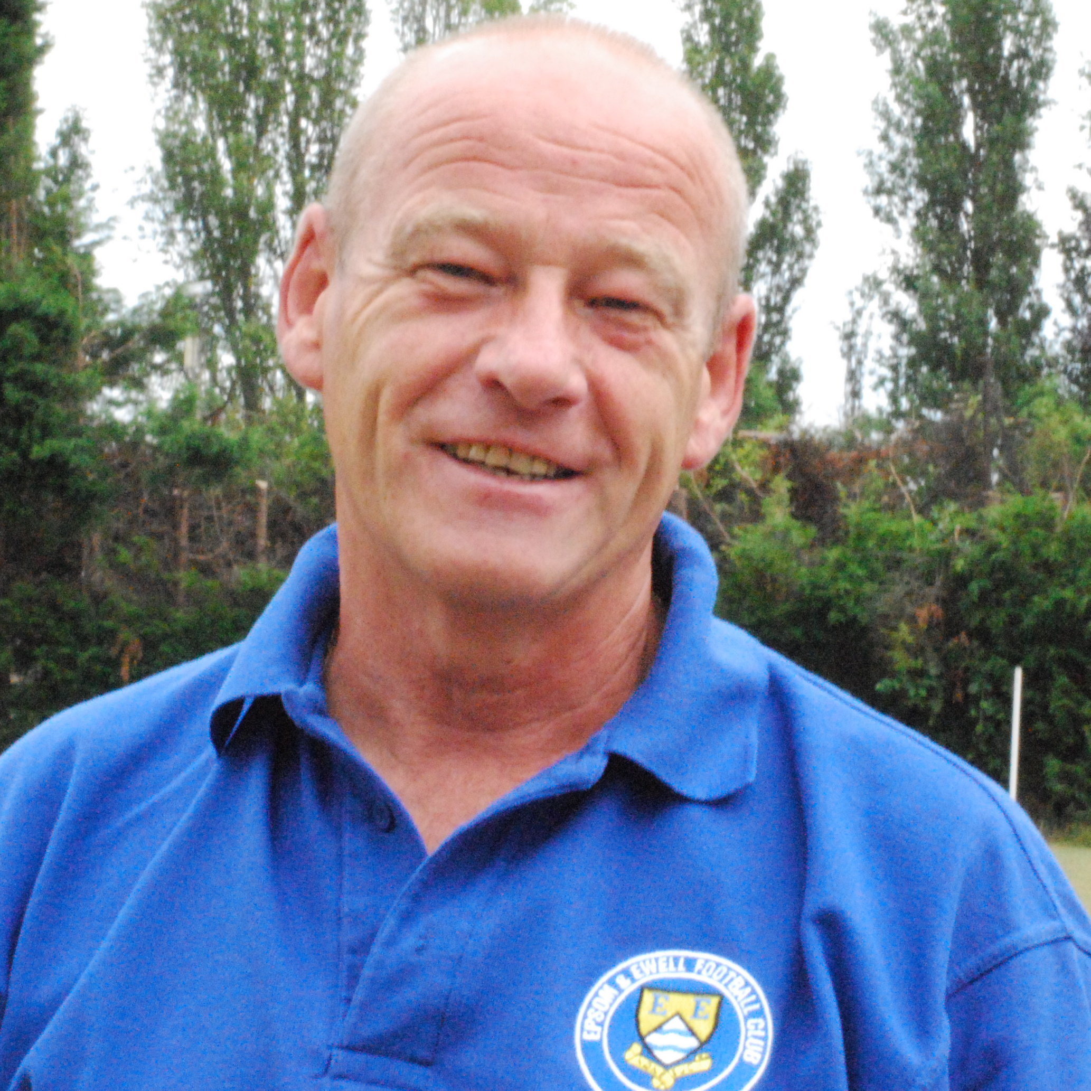
Favourite Football Team:
Manchester United

Favourite Football Player: Eric Cantona

Favourite Ground: Old Trafford

Favourite Food: Steak and Kidney Pie

Favourite Drink: Diet Coke

Favourite Sportsperson: Alex Ferguson

Favourite Music Album:
Bridge over Troubled Water – Simon & Garfunkel

Favourite Holiday Destination: India

Clubs Played for: Epsom, Kingstonian, and Carshalton Athletic and as a Youth, Chelsea, Tottenham and Crystal Palace

Best ground you’ve played at: Highbury

Personal aim for this season: To better last year

Where will we finish in the League: Top Three

Player Sponsorship
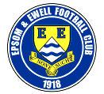 |   Shirts (£25.00) |  |  |   Shorts (£12.00) |   Socks (£8.00)
The cost is shown by each item,
or you can sponsor a player for £40.00.
Speak to Tony Jeffcoate or Richard Lambert.
Ramzi Bedj Bedj | Evan and Jim Gregory
Paul Borg | Freddie Foster
Dan Cormack
Tony Cuff | Bob Clarke
Matt Fowler
Neil Harrowing | Maryse Oakes

Jamie Hatfield
Ben Hayward | Ben Foster
Kyle Hough | Boys behind the Goal
Mark Jarman | Vic McGregor
Tom Jelley
Alex McGregor | Alex, Heather, Mia and Tibo
Tommy Moorhouse
Joe Paris
Jamie Reive
Alex Rodrigues | Pete Beddoe
Dean Sammut | Maryse Oakes
Darren Smith | Barry Barnes
Matt Smith
Peter Solomon
Dave Stevens
Charlie West | Paul Norris
Paul West | Paul Smith
Lyndon Buckwell | Robert Oakes
Tony Coombe
Ken Jones
Barry Barnes

This Season’s Match Sponsors
Fixture | Date |  |  | Match Sponsor |  |  |  | Ball Sponsor
Shoreham (F.A. Cup) | 14/08/10 |  |  | Epsom & Ewell F.C. Committee
Dorking | 17/08/10 |  |  | Pete Beddoe
Mole Vallley SCR | 21/08/10 |  |  | Richard Lambert
Flackwell Heath  (F.A. Cup) | 28/08/10 |  |  |  |  |  |  | Dick & Dom
Molesey | 09/10/10 |  |  |  |  |  |  | Pete Beddoe
Ash United | 19/10/10
Badshot Lea | 23/10/10
Raynes Park Vale | 06/11/10 |  |  | Mid-Surrey Mencap
Bracknell Town  (F.A. Vase) | 14/11/10
Cove | 20/11/10
Chessington &  Hook United | 11/12/10 |  |  | Freeman, Hardy & Willis
Horley Town | 27/12/10
For League Matches:

Match sponsorship is available for £35.00.

Match ball sponsorship is available for £20.00.

For Cup Matches:

Match sponsorship is available for £45.00.

Match ball sponsorship is available for £25.00.

Match sponsorship includes admission,
programmes, advertising and hospitality for two.

Match ball sponsorship includes admission,
programme, advertising and hospitality for one.

Interested? Speak to Tony Jeffcoate on 07960 084225 now!

Photos of the week
For those who missed the Molesey game, we were awarded two penalties that a lot of people disputed. From years of experience, I often find that the best way of judging an important decision is the reaction of the players. Fortunately, Gemma Jarman got pictures of both challenges, and they really do tell the story. See how many players look towards the referee for the first penalty. Maybe the second one was a bit lucky though!
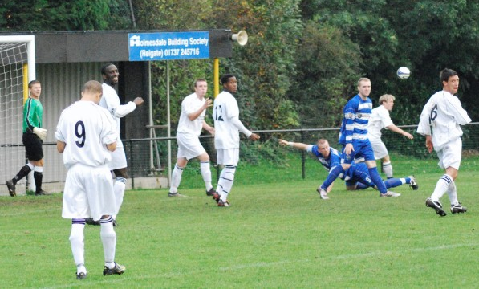
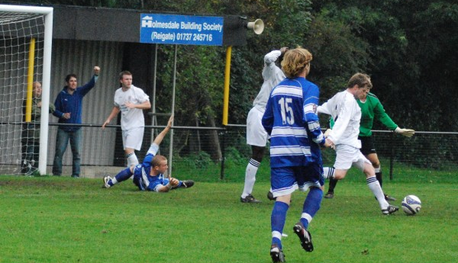

Combined Counties League – Premier Division
Tuesday 19th October 2010 - Kick-off 7.45 p.m.
Epsom and Ewell F.C.  (Royal Blue & White hoops) |  | V |  |  |  | Ash United  (All Green)
Paul Borg |  | 1 |  |  | 1 | Arjuna Adlam
Tom Jelley |  | 2 |  |  | 2 | Stuart Woodhouse
Paul West |  | 3 |  |  | 3 | Lee O’Donnell
(capt) Alex Rodrigues |  | 4 |  |  | 4 | Connor Close
Jamie Reive |  | 5 |  |  | 5 | Cameron Bowditch
Joe Paris |  | 6 |  |  | 6 | Scott Cannie (capt)
Ben Hayward |  | 7 |  |  | 7 | Daryn Hennessey
Alex McGregor |  | 8 |  |  | 8 | Gavin Evans
Mark Jarman |  | 9 |  |  | 9 | Karl Dallaway
Kyle Hough |  | 10 |  |  | 10 | Aneel Azeem
Tony Cuff |  | 11 |  |  | 11 | Stacey Thripp
Jamie Hatfield |  | 12 |  |  | 12 | Craig Parrington
Jack Witts |  | 13 |  |  | 14 | Matt Steer
Matt Smith |  | 14 |  |  | 15 | Kurt Taylor
Dave Stevens |  | 15 |  |  | 16 | Ross Millard
Dan Cormack |  | 16 |  |  | 17 | Taylor Jackson
Lyndon Buckwell |  | MANAGER |  |  |  | Paul Bonner
Tony Coombe |  | ASSISTANT |  |  |  | Mike Scott
Barry Barnes |  | COACH
Ken Jones |  | PHYSIO |  |  |  | Spencer Abbott
REFEREE: A.Mawby (Woking)
ASSISTANT REFEREES: G.Whapshott (Aldershot), R.Stephen (Teddington)

OUR NEXT FIRST TEAM MATCH AT MOATSIDE

Epsom and Ewell v Badshot Lea

Saturday 23rd October - Kick-off 3.00 p.m.
Combined Counties League - Premier Division

